
Test One
Teacher:

Mr Staffe

Mrs. Carter

_____Mr Bertram

_____Mr Roohi

_____Ms Cheng

Semester One 2016
Year 12 Mathematics Methods
Calculator Free
Name:

- Complete all questions
- Show all necessary working
- Total Marks = 25
- 25 minutes

1. [12 marks]

Find 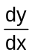 in each of the following, by using the appropriate rule.
(a) y = (3x² − x) (x³ - 4x² – 5x + 3) (Do not simplify) [2]

(b) y = 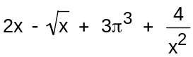 (Leave with positive indices.) [2]

(c) y = 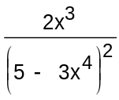 (Do not simplify) [3]

(d) 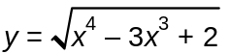 [3]

(e) y = 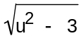 using the chain rule 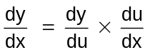 , where u = 2x³ + 3 [2]

2. [3 marks]
Consider the function f (x) = x³ − 5x² − 8x + p where p is a constant.
(a) Determine where the local (relative) extrema points occur. [2]

(b) What can we say about value of p given that two of the three roots are negative [1]

3. [4 marks]
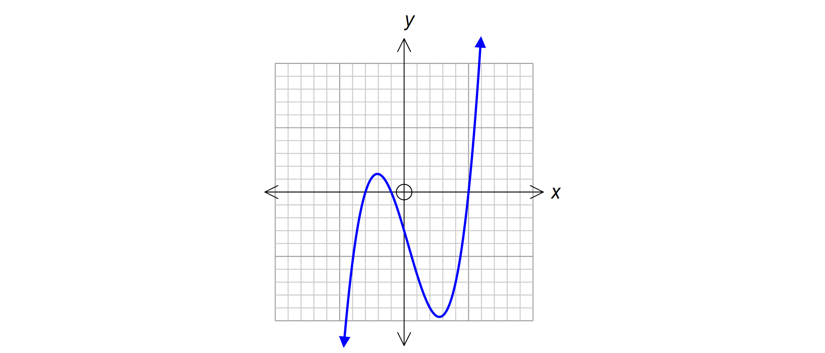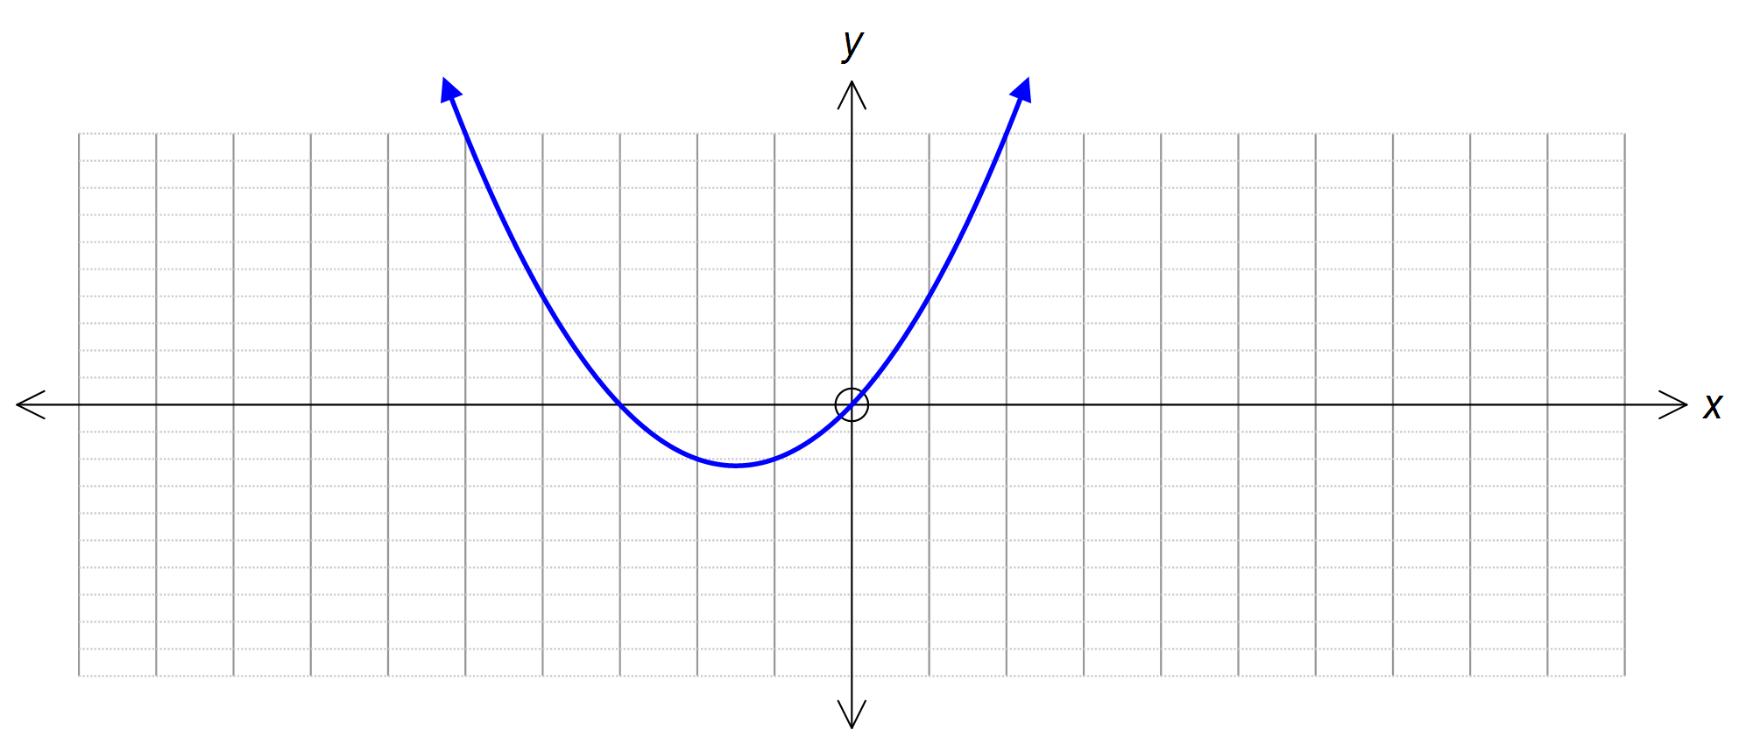 Draw a sketch below of each of the gradient functions formed by each of the following functions
(b)
(a) (b)

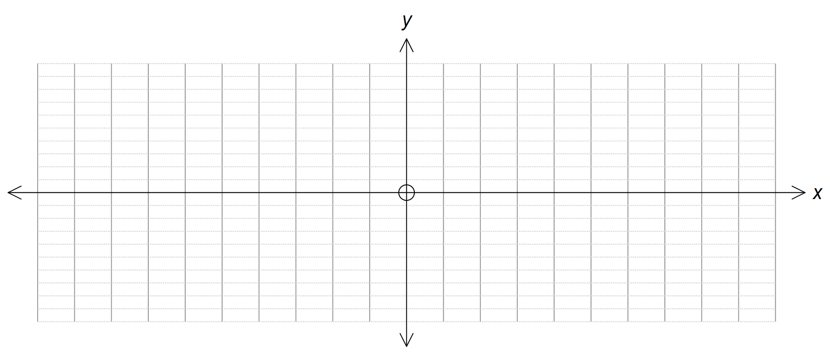

4. [6 marks]

Find the turning points, points of inflection and intercepts for the function
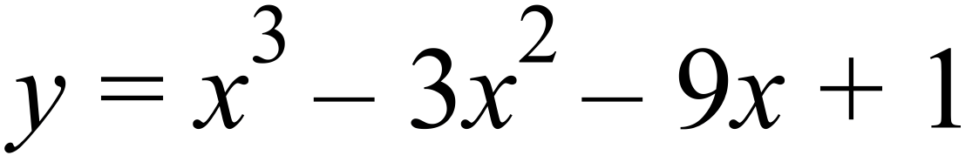 . Then graph a sketch of the function on the axes provided below, clearly showing these key points.

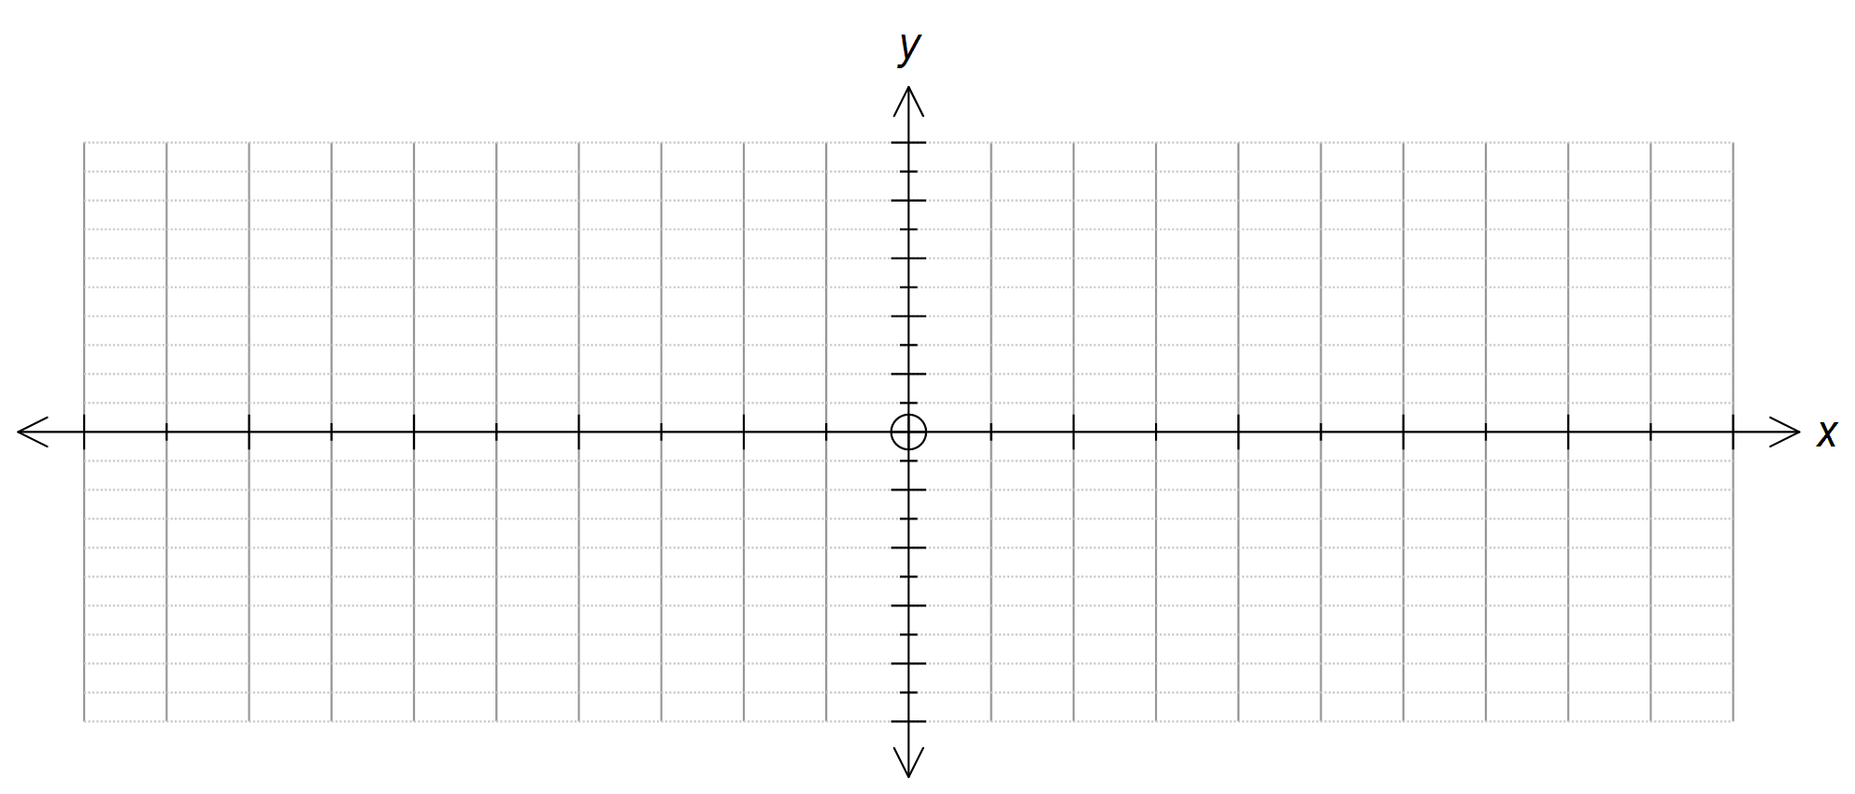

Teacher:

Mr Staffe

Mrs. Carter

_____Mr Bertram

_____Mr Roohi

_____Ms Cheng

Test One

Semester One 2016
Year 12 Mathematics Methods
Calculator Assumed
Name:

- Complete all questions
- Show all necessary working
- Total Marks = 25
- 25 minutes

1. [ 5 marks ]

A particle's position along the x-axis, in meters, is given by the function s =3t³ – 5t +9.
(a) Find the Velocity and Acceleration of this particle when t = 2 seconds [3]

(b) When does the particle stop moving, and how far from the origin is it at this time? [2]

2. [ 8 marks ]

The volume of a certain rectangular box is given by the equation 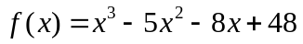.
(a) If the height of the box is 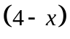units, determine an algebraic expression for the area of the base of the box. [3]

(b) Calculate the value of x for which the volume is a maximum. [5]

3. [7 marks]

- If the volume of a cylinder is given by 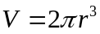, find the appropriate percentage change in V when r changes by % [3]

- If the volume of the solid generated by rotating a shaded region is given by
V = 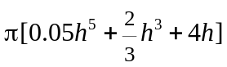 , use the incremental formula, 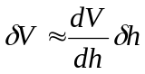,
to estimate the change in volume when h increases from 3 to 3.01. [4]

4. [5 marks]

Sketch the graph of y = f(x) given the data below:
(i) f(2) = - 9, f(- 4) = 27, f(-1) = 9
(ii) 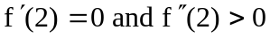
(iii) 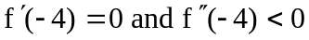
(iv) 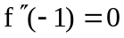
(v) 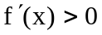 for x > 2, x < - 4
(vi) 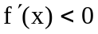 for - 4 < x < 2
(vii) f (0) = 3
